Task 1:

Write an algorithm / steps for selection sort.

Step 1: Find the maximum item in the array.
Step 2: Swap the maximum item with the last element of the array.
Step 3: Find the second maximum unsorted item in the array and replace it with the 2nd last element in the array.
Step 4: Repeat the steps until all the items in the array are sorted.

Task 2:

Write a pseudo code for the selection sort.

Void SelectionSort (int a[], int n) {
for (int i = n-1; i>=1; i–) {
int maxIndex = i;
for (int j = 0; j<1; j++) {
If (a[j] >= a[maxIndex])
maxIndex = j;
}
swap(a[i], a[maxIndex]);
}
}

Task 3:

Wap to make sure your list is sorted using selection sort.

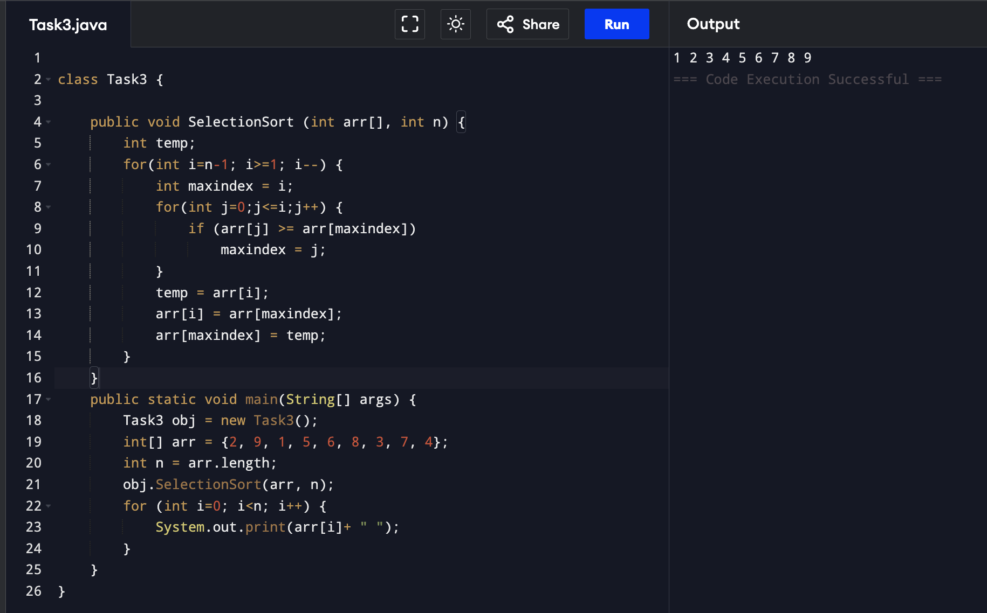
Task 4:

Write algorithm for the Bubble sort.

Step1: Compare pair of adjacent items in the array.
Step2: Swap if the items are unsorted.
Step3: Repeat the steps till the end of the array.
Step4: Now n-1 and repeat the steps for next iteration.

Task 5:

Write pseudocode for the bubble sort

void bubbleSort(int a[], int n) {
for (int i = n-1; i >= 1; i--) {
for (int j = 1; j <= i; j++) {
if (a[j-1] > a[j])
swap(a[j], a[j-1]);
}
}
}

Task 6:
Wap to make sure your list is sorted using Bubble sort.

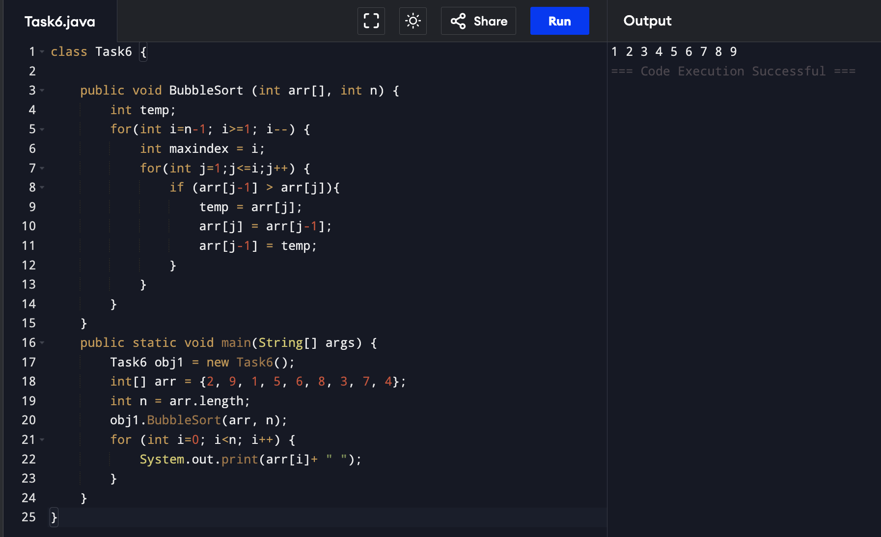

Task 7:

Write algorithm for the Insertion sort.

Step 1: Assign a key (i+1).
Step 2: Compare key with items in the Array.
Step 3: if the key is less than item shift the item to the right and insert the key.
Step 4: if the key is greater than the item update the key to next element.
Step 4: Repeat the steps until all the elements in the array are sorted.

Task 8:

Write psedo code for the Insertion sort

Void insertionSort(int a[], int n) {
for (int i =1; i<n; i++) {
int next = a[i];
int j;
for (j = i-1; j >= 0; && a[j] > next; j–) {
a[j+1] = a[j];
a[j+1] = next;
}
}

Task 9:

Wap to make sure your list is sorted using Insertion sort.

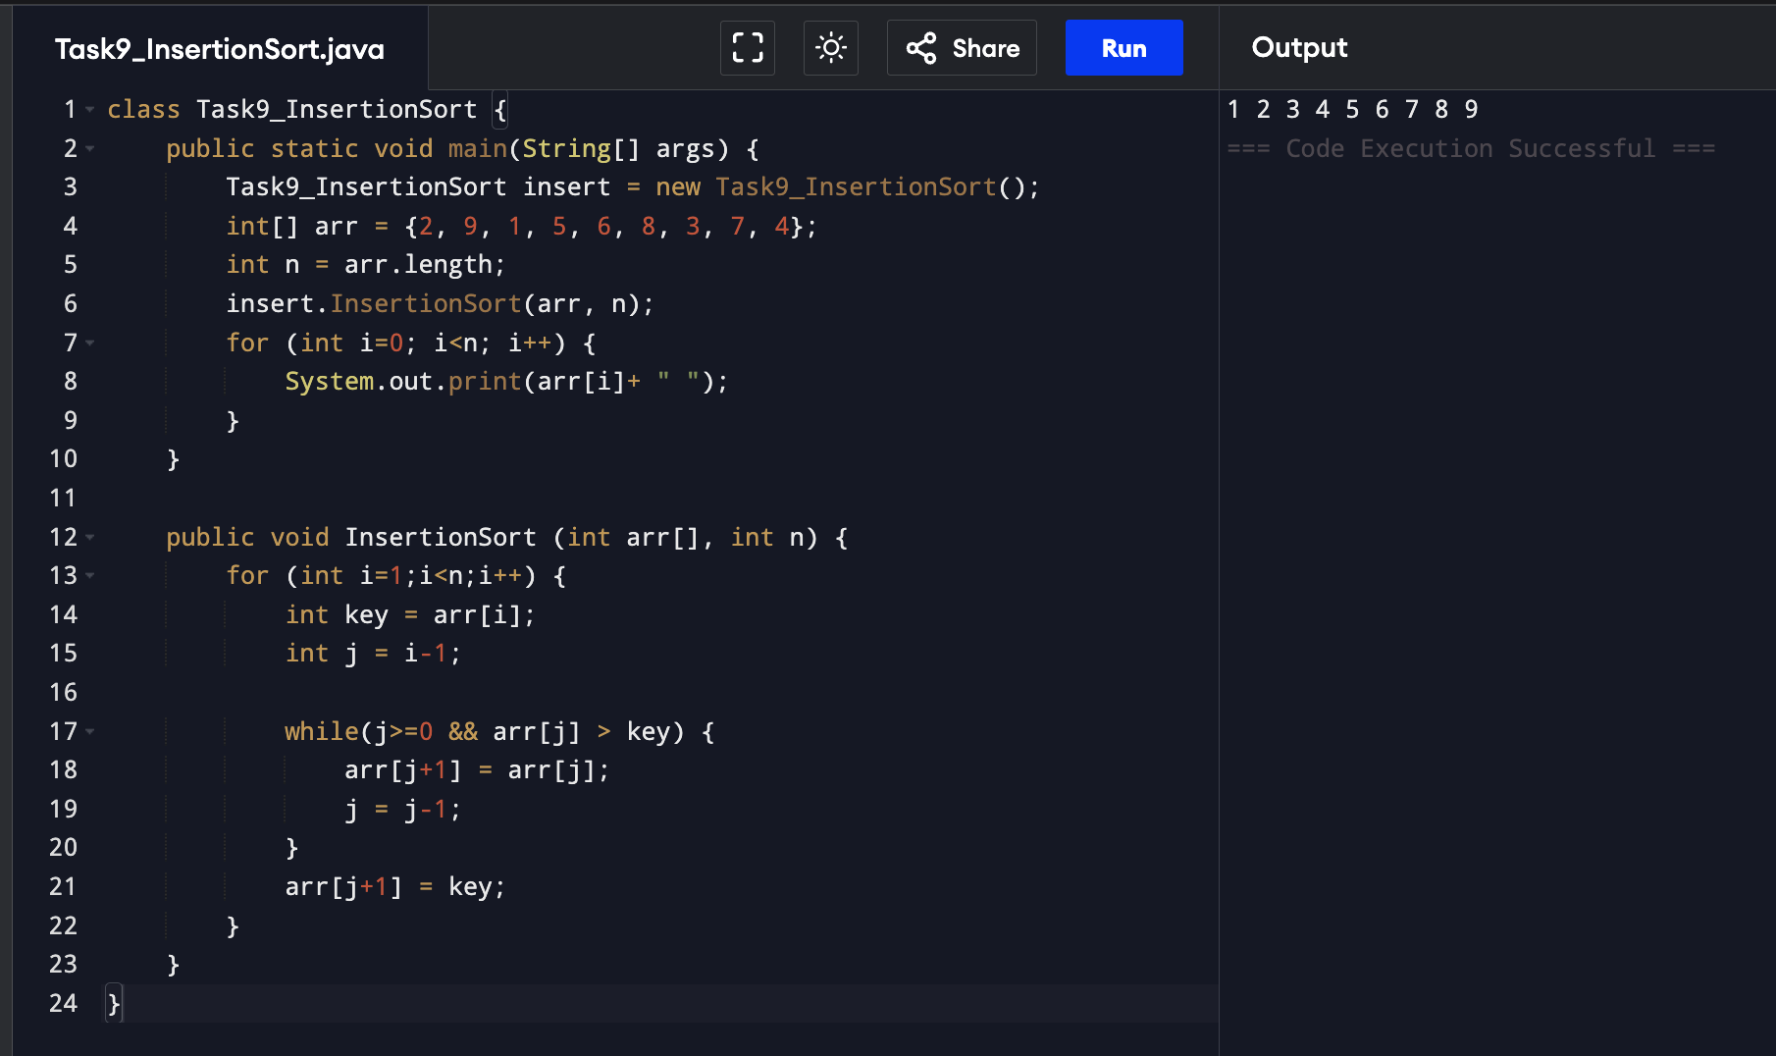

Task 10:

What are the advantages and disadvantages of Bubble sort Algo?
List them

Advantages:
- Space efficient.
- Works best for already sorted data.

Disadvantages:

- Takes more time.
- Less practical application.

Task 11:

Algorithm for merge sort:

Step 1: Split the data till only one element is present.
Step 2: Merge the elements in sorted manner.
Step 3: Repeat the steps until the main array is sorted.

Task 12:

pseudo code for merge sort:

function mergeSort(arr, left, right):
if left >= right:
return

mid = (left + right) / 2

mergeSort(arr, left, mid)
mergeSort(arr, mid + 1, right)

merge(arr, left, mid, right)

function merge(arr, left, mid, right):
create leftArr from arr[left to mid]
create rightArr from arr[mid+1 to right]

i = 0, j = 0, k = left

while i < length of leftArr and j < length of rightArr:
if leftArr[i] <= rightArr[j]:
arr[k] = leftArr[i]
i = i + 1
else:
arr[k] = rightArr[j]
j = j + 1
k = k + 1

while i < length of leftArr:
arr[k] = leftArr[i]
i = i + 1
k = k + 1

while j < length of rightArr:
arr[k] = rightArr[j]
j = j + 1
k = k + 1
Task 13:

Merge sort code

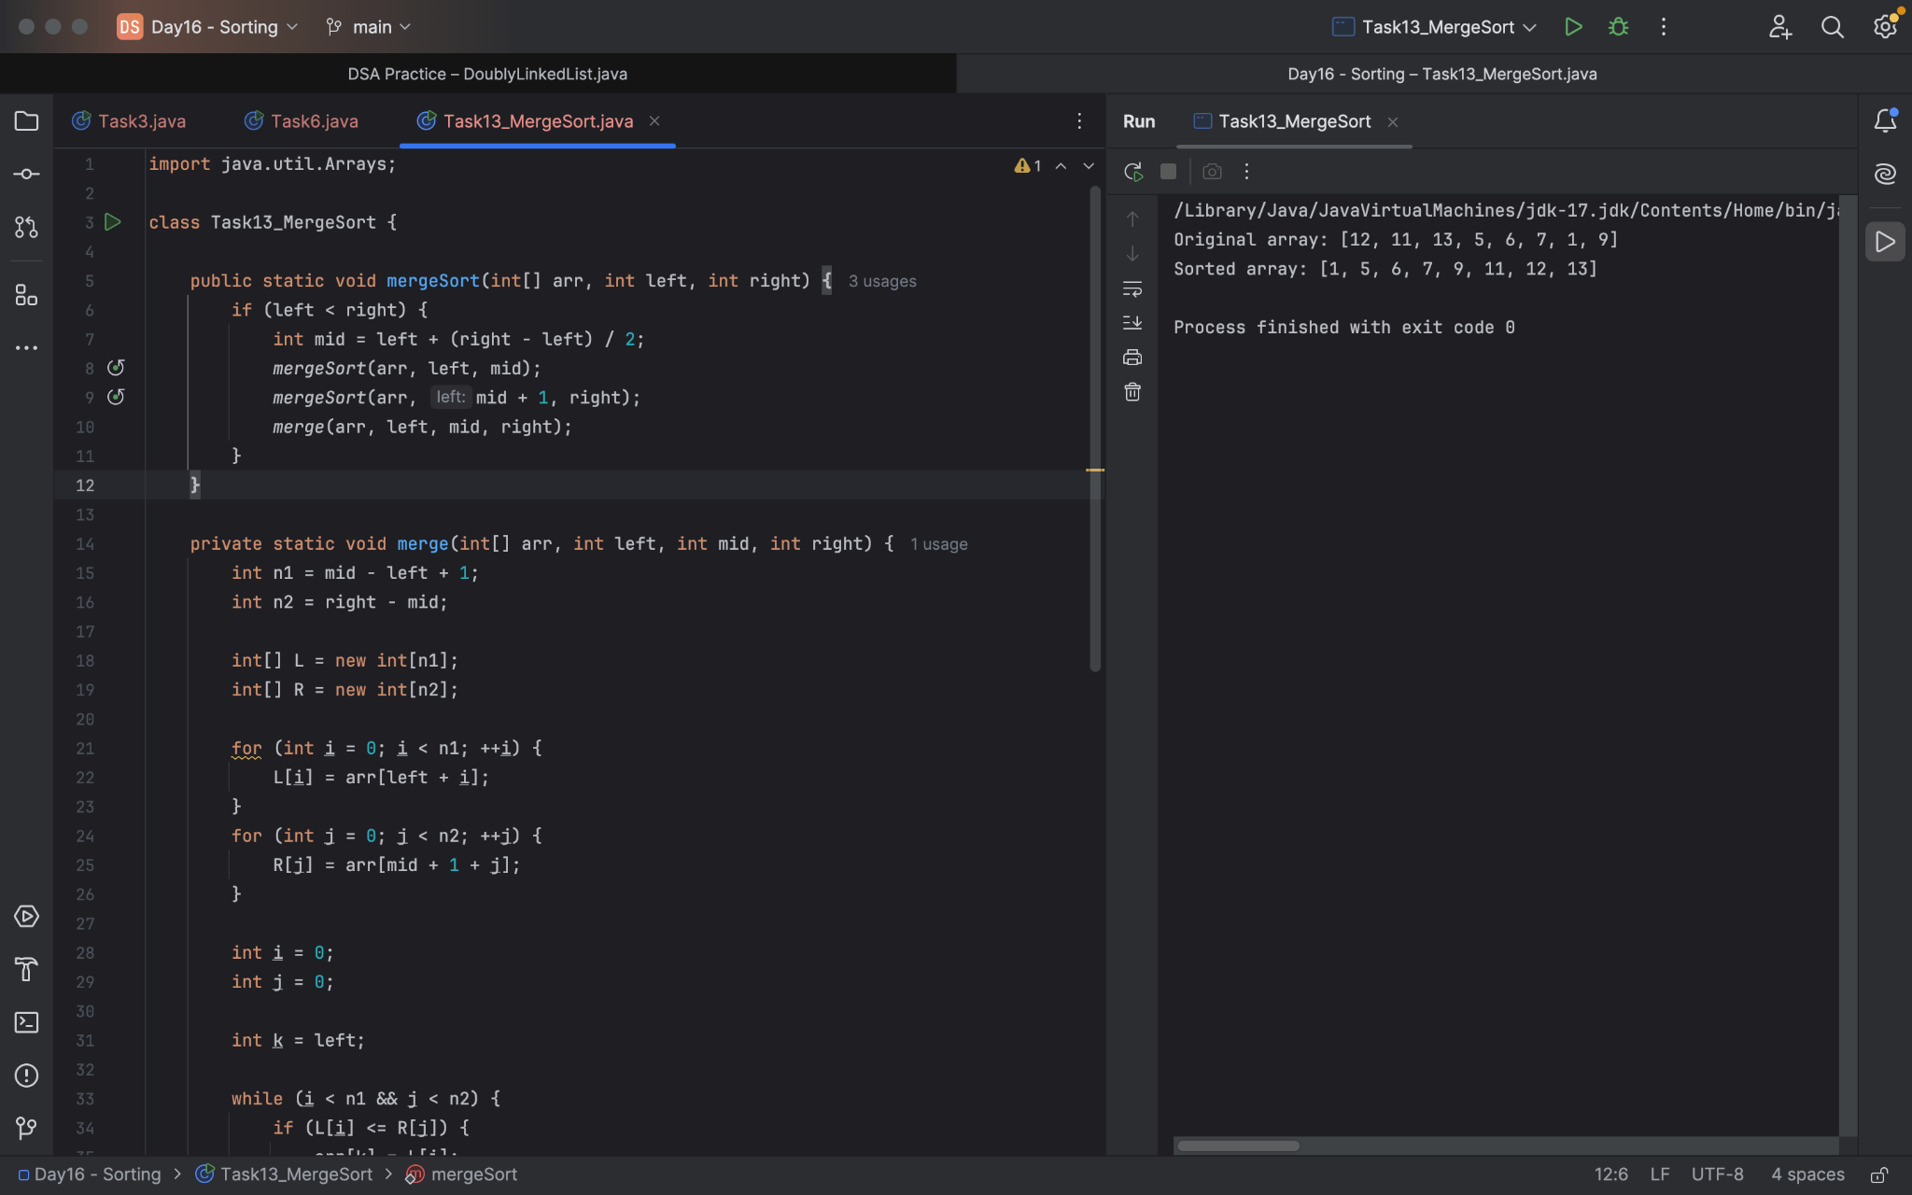

Task 14:

Quick sort: algo

1. Choose pivot
2. Take two variables to point left and right of the list excluding pivot
3. Left -> low index
4. Right -> high
5. Whle value at left < pivot move right
6. While value at right > pivot move left
7. If both step 5 and step 6 does not match swap left and right
8. If left ≥ right, the point where they met is new pivot

Task 15:

Quick sort pesudocode:

QUICKSORT(arr, low, high)
if low < high
pivotIndex ← PARTITION(arr, low, high)
QUICKSORT(arr, low, pivotIndex - 1)
QUICKSORT(arr, pivotIndex + 1, high)

PARTITION(arr, low, high)
pivot ← arr[high]
i ← low - 1

for j ← low to high - 1
if arr[j] < pivot
i ← i + 1
swap arr[i] and arr[j]

swap arr[i + 1] and arr[high]
return i + 1

Task 16:

Program for quick sort

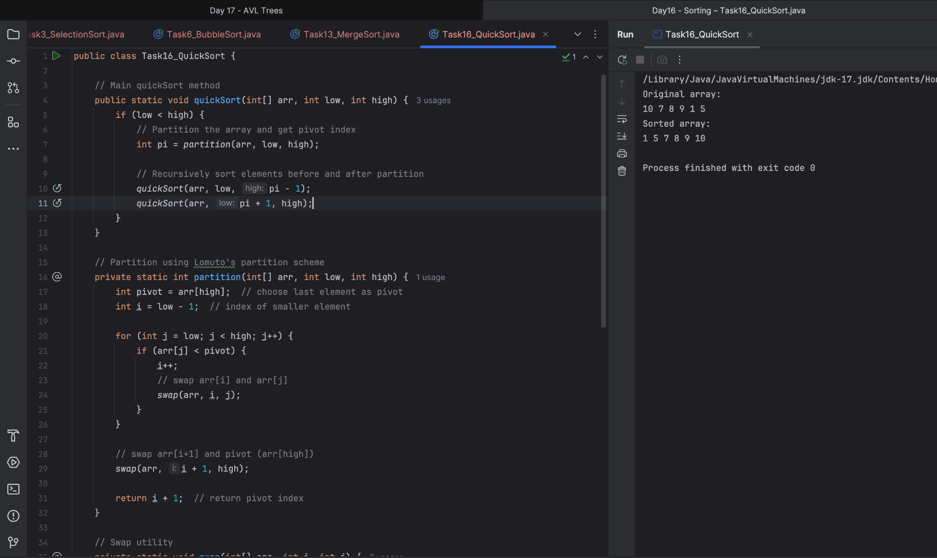

Task 17:

Which one is better merge or bubble in terms of time complexity.

- Merge sort is better than bubble sort as merge is efficient in terms of time complexity as well as stability in terms of preserving the order of insertion.
- Merge sort is preferred for larger datasets.
Task 18:

Leet code qn:

Find the time complexity of the given merge operation between two sorted array.

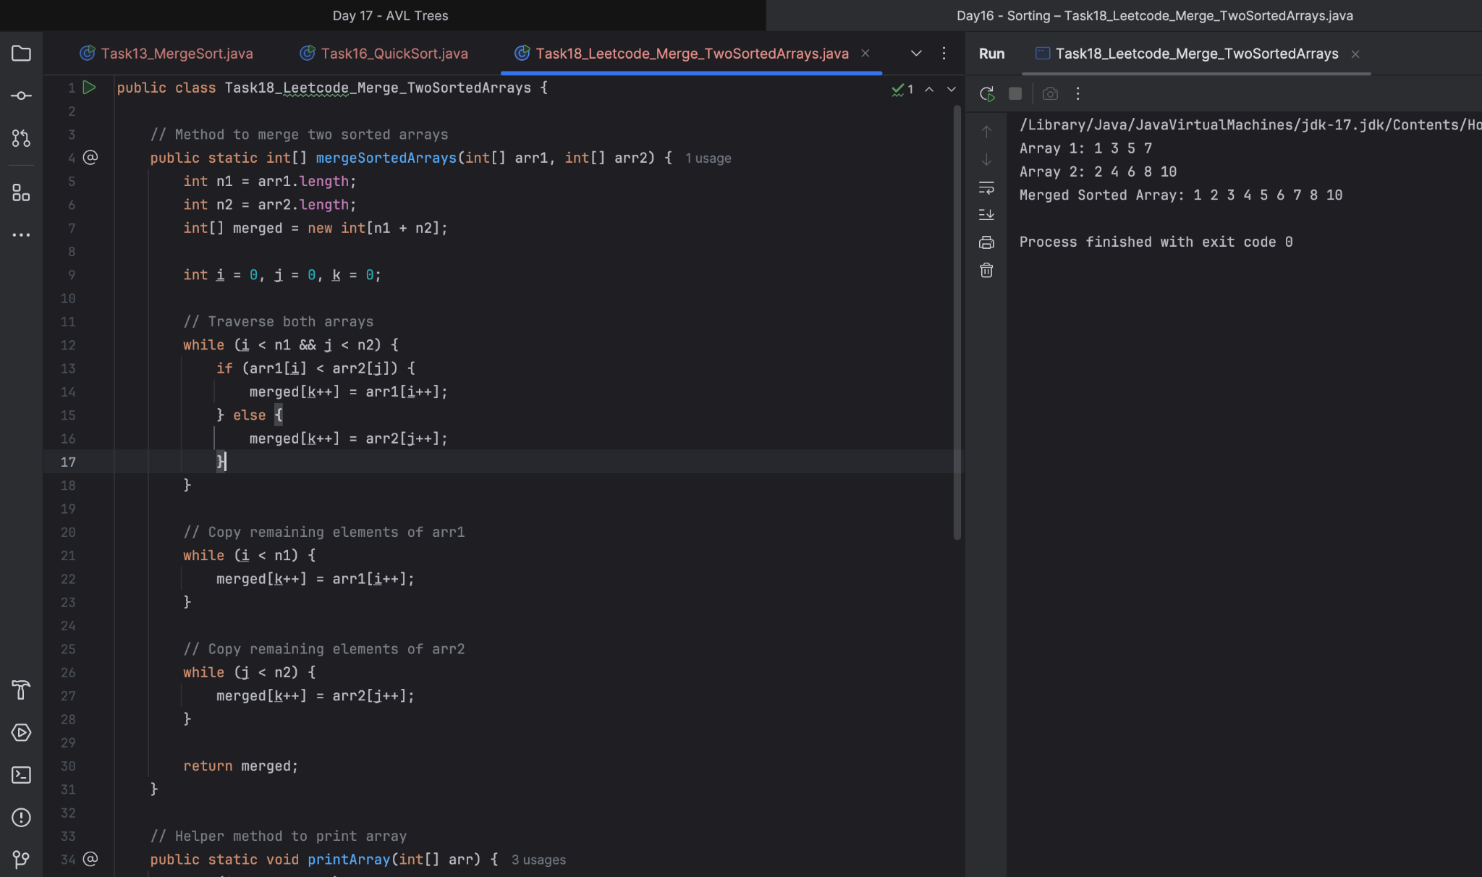

Task 19:

This code is going overflow of stack.. Can you plz help me fix it guys..

public class RecLoop {

public int calc(int n) {
if (n == 0) return 0;
return n + calc(n);
}

ANS: The above code is having a recursion call that does not satisfies the base condition (n==0) since we are incrementing n and not decrementing it. Thus the function calls accumulates in stacks and none of the function is returned and called infinitely stack overflow occurs. We can decrease the value of n and when the base condition (n==0) is satisfied the function is returned (0). Then stack memory is cleared.

Task 20:

public class BinarySearchNew {
public int search(int[] arr, int toFind) {
int left = 0, right = arr.len - 1;

while (left <= right) {
int mid = left + (right - left) / 2;

if (arr[mid] == toFind) {
return mid;
} else if (arr[mid] < toFind) {
left = mid + 1;
} else {
right = mid - 1;
}
}
return -1;
}
}

binary search function can we use in unsorted list?
Will it give you correct index no?

ANS: The Binary search function should not be used in an unsorted list/array. It does not provide correct solution.

ADDONS:

- What is the difference between binary tree and binary search tree (bst)
Can you explain diff between structure and operation of Binary tre and BST.

ANS:

A binary tree is a tree data structure in which each node has at most two children (left & right). No order property. Nodes can have any value.

A BST is a special kind of binary tree where:
- Left subtree nodes < parent node.
- Right subtree nodes > parent node.
Ensures fast search, insert, delete: O(log n) if balanced.

- In sorted array why do you think binary search tree is best than linear search.. Can you explain plz.

ANS: Binary search is better in BST because in BST value less than root/parent are on the left and value greater than root/parent are on right which is kind of sorted where if the value to be searched can be easily found using divide and conquer. TC: o(log n). For linear search worst case TC would be o(n).

- Difference between static and dynamic arrays.. Plz list them

Static Arrays: Fixed size, declared/initialized at compile time.
Dynamic Arrays: Size can be expanded/shrinked, Arraylists in java.

- In BFS, DFS which one is more preferred in terms of shortest path for the unweighted graphs.

BFS/level order traversal is more preferred in terms of unweighted graphs.

- Write a code to implement a stack using an array.

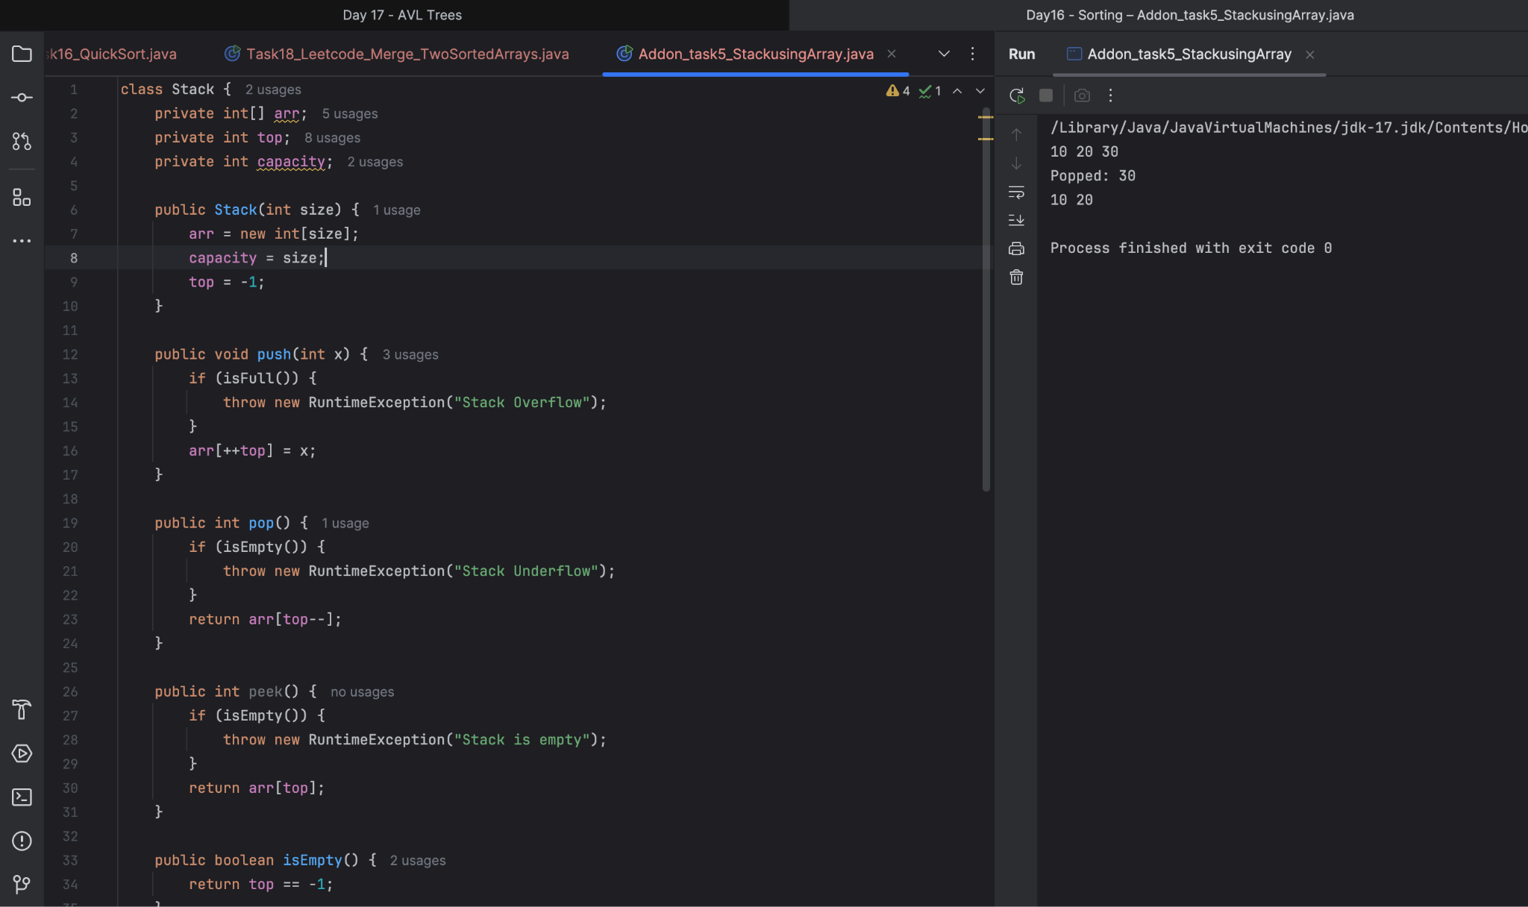
- Pre order and post order traversal..

Preorder:

void preOrder(Node node) {
if (node != null) {
System.out.print(node.data + " ");
preOrder(node.left);
preOrder(node.right);
}
}

PostOrder:

void postOrder(Node node) {
if (node != null) {
postOrder(node.left);
postOrder(node.right);
System.out.print(node.data + " ");
}
}

